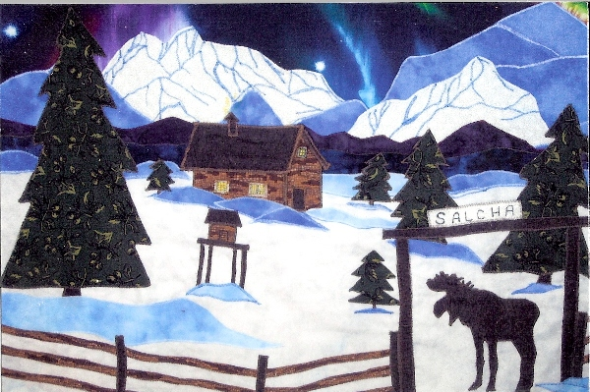
Entered on part of the State 50th Anniversary Quilt that is currently touring our State for Alaska 50th Anniversary of statehood.
Created by: Eleanor J. Boehlke
Carolyn Calkins
Cindy Jeffries
Entered through : Salcha's Neighborly Organization
More information

SNO BALL
Dec.27th 6:00 PM
Salcha Seniors
Live music, Dancing, Food
Free Admission
Join your neighbors.
for information, Call 488-6420
488-7114 or 488-2320

Afternoon workout at the
Salcha Senior Center
Monday and Wed. at 5:30pm
You can call Rhonda at 488-5802
for more information.

PUBLIC MEETING
Community Center Development,
Planning Session
at the
SALCHA SENIOR CENTER
SATURDAY
NOVEMBER 15, 2008
5-7 PM
After our first full sized "stake-out" of the community center, we realized some limitations in our building design, your ideas and experience can go a long way towards developing a building that would be a icon for what Salcha stands for. Several points here, Alaska is wanting to be on the cutting edge for eco friendly, energy efficient buildings. The Borough is more than willing to provide services to Salcha, library, transportation (park and ride Bus Service). For Salchans, Showers, Laundry, food distribution, a gathering place. Increased taxes, NO! Being operated by a non-profit, we can make it a self supporting cooperative. Please come share your ideas, pro's and con's. What is SNO?

The Markgraf Family would like to thank the Salcha Community for their sympathy and allowing the family to grieve privately.
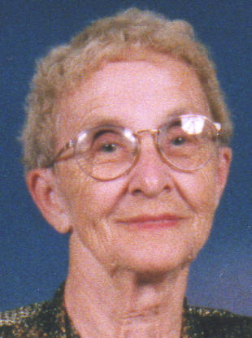 | Lois Markgraf  January 9, 1920 to October 7, 2008
Longtime Salcha resident, Lois Markgraf passed away at home with her family by her side, at the age of 88.
Lois was born in North Dakota, along with her twin sister, Louise. She was raised in International Falls, Minnesota and attended business college and worked in Minneapolis. During World War II she worked in Whitehorse, Canada where she met and fell in love with her husband, Richard (Dick) Markgraf. Following a six week trip down the Yukon River, they were married in Fairbanks in 1944 and moved to the Salcha area in 1946. She and Dick owned the Salcha Sport Shop for more than 30 years, which was a vital part of the Salcha community.
Lois was the first secretary for the Salcha School in 1964 and then worked on Eielson AFB as the secretary of Taylor Junior High from 1966 until she retired in 1979.
Lois’ contribution to the Salcha community was vast and her loving dedication to her family unfaltering. Her life was all about nurturing and helping children and she never met a person that she couldn’t find the good in them and they, in turn, found it in themselves. “She was a best friend, a wonderful mom and grandmother and she never met a stranger. She will be greatly missed but will live on in our memories and our hearts,” said her family.
Lois was preceded in death by her husband, Richard Markgraf and son, Rick Markgraf. She is survived by son Fred Markgraf (wife Melissa) of Salcha, daughters Penny Little (husband Larry) of Soldotna, Alaska and Robyn Schmitt (husband Len) of Bozeman, Montana; by her grandchildren Richard, Tryna, Penny, Brandi, Kelli, Ryan, Brittany, Brianne, Harley and Rikki and by her great-grandchildren Tristan, Paige, Elyse, Kyrstin, Kyra and Shayde.
At the request of Lois, there will be no service, only a family gathering. In lieu of flowers, the family would appreciate donations to the Salcha Rescue at 7153 Richardson Hwy, Salcha, AK 99714, who we truly appreciate.

State Disaster Assistance
For Individuals and Families in the Fairbanks North Star Borough, City of Nenana, the Denali Borough, Village of Wainwright, the City of Kaktovik and Yukon-Koyukuk REAA, who sustained damages to their primary residence, personal property, and transportation during the July/August 2008 flooding event.
To apply, call toll free
1-800-921-3682
(Monday – Friday, 9 am – 6 pm)
Please have the following information with you when you call:
- Description of damages and/or losses
- Damage and/or loss estimates
Insurance information
Applicants needing an interpreter or with hearing disabilities should have a representative call the 1-800 number so arrangements can be made to take your application.
The deadline to apply for State Disaster
Assistance is:
October 3, 2008
Disaster assistance is available without regard to race, color, sex, religion, national origin, age, disability, or economic status.
more info

Mardi Gras Bingo
SATURDAY, OCTOBER 4, 2008
No little children please!
Dinner: CAJUN FOOD by Cajun Joe Procell and Charlene Boberick. Cost is $7.00. Starts at 5PM
Bingo: 16 games for $12.50. Win prizes in lieu of money. Starts at 6PM
Dress up if you want or just wear a mask and beads.
The building has a new foundation, new entryways, new windows, ceiling lowered, new light, painted and etc. Come and see!!!
This is a fund-raiser for the GOL (Gifts of Love) Program. Making sure families have a nice holiday.
Go past the Knotty Shop in Salcha about 2 miles and turn left on Johnson Road. Take the first left and then another left. There will be signs. For information call 488-5802 or 378-4963.
Please come and support the Salcha Seniors while you are having fun!!!

Notice for Saturday the 27th of Sept.
at noon Community Pole Barn Raising and Pig roast. Need volunteers to come and lend a hand and we will have a 110lb pig to roast and we will get a couple of pony kegs we will provide cole slaw potato salad and baked beans with rolls and if some one wants to bring a potluck dessert that would be great. Also I am trying to get the sfa meeting for Sunday the 28th @ 3:00pm that is the official time. Peggy 488-4556

More News coming soon, Saturday September 20th 2008 a SNO gathering and community picnic. Looking for ideas and creative innovations for the Salcha Community Center Project
please submit any input to mmills@salcha.org
Printable flyer

The well at the fairgrounds passed the safe water test, There are four items one, no coliform two, no E.coli, then there are two blocks satisfactory and unsatisfactory, the well is satisfactory, no other options to choose.

Chena Hot Springs
Energy Fair
Saturday August 23
Click for more info

State Disaster Assistance
Salcha Senior Center
6062 Johnson Rd.
Wed. Aug. 13 through Wed. Aug 20
10 a.m. – 7.p.m.
The deadline to apply for State Disaster Assistance is:
October 3, 2008
More info

Post flood information
http://www.uaf.edu/ces/publications/freepubs/SAL-00005.pdf

Senior Quality of Life Assessment

State Implementing Individual Assistance Program for Victims of Northern Alaska and Interior Flooding Disaster
State assistance hotline to open on today for tele-registration
CAMP DENALI, Alaska — The Alaska Division of Homeland Security and Emergency Management (DHS&EM) opened the tele-registration for the State Individual Assistance Programs on August 4th. The program is designed to provide assistance to individuals and families who suffered damages and/or losses to personal and real property during the flooding disaster that struck several communities along Alaska’s interior river systems and coast in July/August of this year. The affected areas include the Fairbanks North Star Borough, the village of Wainwright and the City of Kaktovik in the North Slope Borough, the City of Nenana in the Yukon-Koyukuk Regional Educational Attendance Area, and the Denali Borough.
“Individuals and families in the affected areas who incurred damages or losses as a result of the flooding may be eligible for State assistance through the Individual Family Grant and Temporary Housing program,” said Division of Homeland Security and Emergency Management Director John Madden. “If an individual or family qualifies, they could receive assistance for property repairs, replacement of lost items and temporary housing.”
Those wanting to apply for State assistance should call DHS&EM at 1-800-921-3682, Monday through Friday from 9 a.m. to 6p.m. starting August 4th. Applicants will be asked to provide a description of damages, photographs or videos, ownership documents for transportation and real property and insurance information. Disaster Assistance Centers will be established to take applications and conduct verification of individual household damages. Applicants with hearing disabilities should have a representative call the 1-800 number so arrangements can be made to take their applications.
The deadline to apply for this disasters State’s assistance program is October 3rd 2008.

The FNSB will be sending well water test kits out to Salcha on Monday; they will be available for pickup at Salcha Rescue #1 near Johnson Rd. Tests are for e.coli and chloroform. They are free.

The well at the fairgrounds has been compromised by surface water
Boiling is the safest way to sanitize water. Bring water to a rolling boil for at least 1 full minute and let the water cool before drinking. Water can be treated with bleach, add 16 drops of non-scented bleach to one gallon of water, stir and let sit for 30 minutes. The treated water should have a slight bleach flavor, if it does not, repeat the treatment or find another source of water. Whenever possible avoid contact with flood waters that may contain human or animal fecal matter and/or other harmful contaminants.
There is potable water in the large tank next to the cabin.

On Aug. 4 the Richardson Highway alongside Eielson Air Force Base will be closed from 3:35 to 4:35 p.m. and again from 5:55 to 6:20 p.m. for security purposes during President Bush's visit to the Interior of Alaska

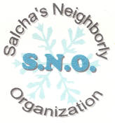 | S.N.O. is here.

2008 Salcha Country Fair
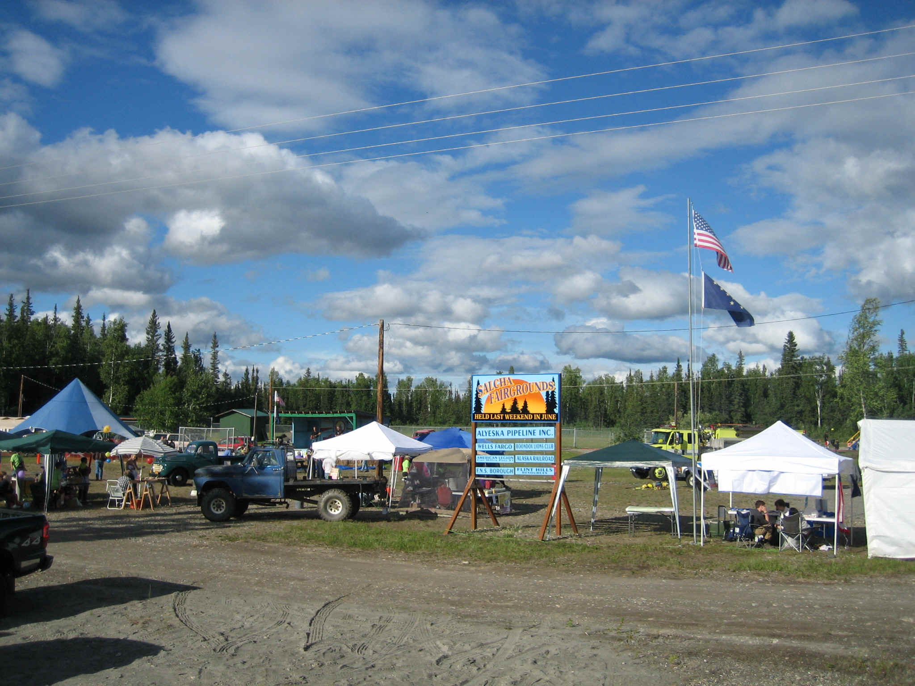

Salcha Country Fair
"Green is Great in 2008"
June 27, 28, and 29
More Info

LOOKING FOR VENDORS & ENTERTAINERS
For more information on Fair booths, crafts, projects, events, ideas or to help, Call Peggy Burns at 488-4556 or email us at salchafair@alaska.net
Sponsored by: Salcha Fair Association
apply on line
Rondy Traders, Local Crafters and Non-profits FREE

Multi-Family Garage Sale @ 6861 Canaday Road from June 26-29. The time will be 8am to 6pm and maybe longer if needed. Something for everyone. A lot of great stuff for a cheap price. It will be the same weekend as the Salcha Fair so stop by and visit. You can call Rhonda at 488-5802 for information. There will be signs.

S.F.A.
Community Center Cookout
DISCOVER YOUR CENTER
Saturday
May 24th
2:00 - 4:00 PM
Guest Speaker: United Way Volunteer Coordinator Beverly Fantazzi
Guest Entertainer: Local Musician Fred Markgraf
Recognize Local Volunteers: Peggy Burns and Morrie Mills
Main dish will be provided, bring your own favorite dish.
CONTACT: Zeenet Kahn 488-6077
Preview Proposals, Development Plan, Floor Plan and Business Plan

Multi-Family Garage Sale
Salcha Elementary Parking Lot
Saturday, May 17
9:00AM-1:00PM
Set-up (for those who've reserved tables) is at 8:00AM

BINGO May 10th 5:30 pm- 6:30 pm Dinner $7
BINGO - 6:30 pm Cost $12.50 Prizes will be awarded in lieu of cash. North
Pole Santa’s Senior Center 101 E. 5th Ave. Call 488-4663 for information
between 11 am - 3 pm.

Mother’s Day Brunch May 11th 10 am - 2 pm. North Pole Santa’s Senior Center 101
E. 5th Ave. $8 Adults and $4 for children under 6. Tickets can be purchased at
the Center between 11 am - 3 pm or call for reservations 488-4663. Tickets will
also be available at the door.

Rummage Sale

Salcha Elementary School

Saturday May 3rd 2008
1:00 pm to 5:00 pm

The dates for the senior sale has changed to April 25-26 and not in May.
Senior garage sale is going to be in May. We are collecting donations now. You can call Phyllis at 488-1664, Sharon at 488-2512 or Rhonda at 488-5802.

Attention Parents
The Alaska Parent-Teacher Association will host its annual state-wide convention in Fairbanks on April 17-19, 2008 at the Fairbanks Westmark Hotel and Convention Center. There will be workshops, speakers, exhibitors and celebrations. Adults and teenage students may attend. All members of the community are welcome to attend the Kick-off reception on April 17. PTA members and interested parties may register by contacting the state office at 1-888-822-1699 (akpta@alaska.net) or the convention coordinator at 488-6185.

Senior Center
Sat. April 19 the Girl Scouts, Troop # 137, are having a chili dinner/bingo find-raiser at the senior building. Dinner starts at 6pm and bingo at 7pm. This is to help the girls raise money to go to summer camp. The dinner costs $6.00 and bingo is $10 for 12 games. Prizes will be given for the winners of the bingo games.

Development Meeting
Thursday April 17
7:00 pm
At Salcha Senior Center
Your input is important, we need to know what your concerns are, services we can provide so you don't have to drive to town. The unique thing that we are doing, we are not a political entity, True, it will be on Borough owned property that the Salcha Fair Association (501-(c)-3 non-profit) leases. It will not effect property taxes due to the fact the Center will have to support itself. We are looking at a co-operatetive type of support, if you can't pay with money, you can donate time. Some job opportunities may become available as other agencies come to the Center. More Info

Salcha Fair Association Meeting
7:00 pm at the fairgrounds cabin
Tuesday April 8th

The War on Men and the family
He's still on the ballot

Citizens advisory position

Senior Center
Sat. April 5 is our Bingo/dinner fundraiser. The dinner is $6.50 and starts at 5pm and the bingo is $12.50 and starts at 6pm. We are serving meatloaf, mashed potatoes, peas, cold-slaw, rolls, dessert and coffee.

Obama - Clinton
McCain - ?
What is the media hiding?

Community Easter Egg Hunt
Sat. March 22nd at 12:00 Noon SHARP!
6th grade and under.
Once we turn the kids loose, the eggs are gone in seconds.
Held at the Salcha Fairgrounds.
Hot Dogs, Chips and Beverage provided FREE!
Small goodie bag for each child.
Hosted by Lori Lovan
For more information or to help call Lori at 488-0803 set up begins at 9:00 am

Salcha Fair
Slogan Contest
The 27th Annual Salcha Country Fair needs a slogan! The 2008 Fair dates are June 27th, 28th and 29th. The Salcha Fair Association would like to offer a $20.00 cash prize for the best slogan submitted. Also, free admission to them and their immediate family for a day.
Please submit your slogan by March 15th to Shelly at the school office or P.O. Box 140086 Salcha, Alaska 99714

Salcha Fair Association meeting
Cabin at the Fairgrounds
Tuesday March 11, 2008
7:00pm

The first Community Center Development Committee meeting will be held at the Salcha Senior Center, Wednesday, March 12, 2008, at 7:00p.m.

Salcha Area Open House
The Alaska Railroad will be hosting a open house at the
Salcha Senior Center
6062 Johnson Road
Thursday, March 6th, 2008
4:00-8:00 p.m.

CHILI FEED FUNDRAISER
FOR THE SMITH FAMILY
There will be a chili feed with cornbread and dessert on Saturday, March 1 FROM 5-8 PM AT THE SALCHA SENIOR BUILDING. This is off of Johnson Road. Follow the signs. To pay for the meals we are accepting donations (no set price)
This is to raise money to help Jewell smith and his family whose house burnt down a few days ago in Salcha close to the Knotty Shop.
Their granddaughter who they have raised is a junior at Ben Eielson. They lost everything and are staying on Eielson AFB at this time.
Please come and help support this wonderful family. This could have been anyone of us!
If you would like information to help in anyway or just donate you can call Rhonda or Joe Procell at 488-5802 or 378-4963.

2008 Compass II
Community Visioning Session
Carlson Center
Sat. March 1st 8:30 am to 12:30 pm
More information

Meeting
Salcha Fair Association
Feb. 12th at 7 PM
Fairgrounds Cabin

WANTED
COMMUNITY INPUT
Be in on the ground floor of building the
SALCHA COMMUNITY CENTER
1st of a series of meetings
THURSDAY FEB. 7th @ 7 p.m.
At the SALCHA SENIORS
Looking for ideas, suggestions, advice and Positive energy
With support from
The Salcha Fair Association
The Salcha Seniors
FNSB
Your Neighbors
&
You
PEACE
Letter of intent

Fair Meeting
January 16, 2008
7:00 PM
Come on down and have some fun.

Community Meeting
Salcha Senior Center
Jan. 8th 2008
6:00 PM
Lack of Police Protection in Salcha
John Harris, Pete Felman, Alaska State Troopers and Possibly Gene Therriault will be there.
This is the time for our community to join together and demand better protection.
Bring your complaints and comments. If we don't get a big turn out, the troopers can say we aren't really concerned about our community.

